**E-COMMERCE BUSINESS PLATFORM AMAZON LAUNCHES ‘BILL TO SHIP TO’ FEATURE**

**Suggested URL:** [**https://www.w3era.com/amazon-launches-bill-to-ship-to-feature**](https://www.w3era.com/amazon-launches-bill-to-ship-to-feature)

The E-commerce business platform Amazon launches the ‘Bill to Ship to’ feature.



Amazon is the world’s largest online [E-Commerce](https://www.w3era.com/ecommerce-seo-services/) platform with over 155 million page views every day. The company offerse-commerce cloud computing servicesto small and large businesses that require a flexible, highly scalable, low-cost, and secured solution for online sales and retailing.

**To know about our services visit here:** [**https://www.w3era.com/contact-us/**](https://www.w3era.com/contact-us/)

Amazon business has announced the launch of the ‘Bill to Ship to’ feature. This feature aims to give a chance to business clients with GST registration in just one state to claim tax credit scores for orders delivered throughout the information. Amazon Business clients who’ve GSTIN registration for one or few states but need to take their shipments delivered throughout the nation can now conveniently use this feature and handle their indirect workplace bills higher.

**Let’s connect with us to know latest updates:** [**https://www.w3era.com/**](https://www.w3era.com/)

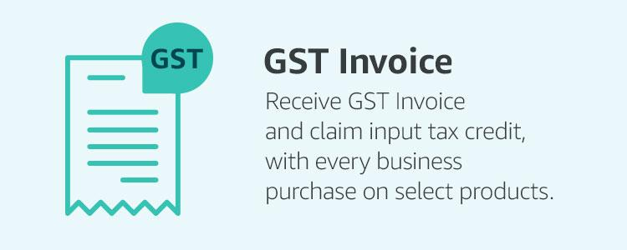

**Director of Amazon Business Peter George said-**

**“We understand the importance of GST credit for our customers and are constantly working towards improving their experience on the Amazon Business marketplace. With the launch of the ‘Bill to Ship to’ feature, we have taken a lead in solving this unique customer problem and offered a solution that allows them to claim GST credit on their billing address for their pan-news shipments. This convenient feature allows customers to consolidate the tax credit to one state and make use of GST credit more effectively.”**

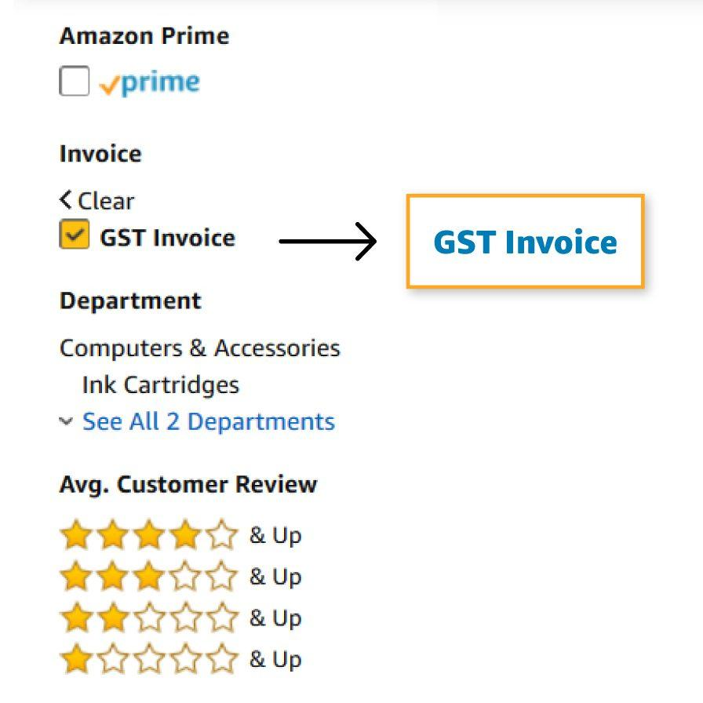

Till now, [Amazon Business](https://www.w3era.com/blog/) clients had been proficient in getting GST invoices only for the orders shipped to a state place that they had a GSTIN registration. This assisted buyer's inconvenience as the billing holder on the invoices had been the same as the shipping address, and the clients who didn’t have GSTIN for the shipping address couldn’t report GST Input Tax Credit for such orders. The ‘Bill to Ship to’ feature is intended to deal with the invoicing considerations of such organizations. So long as clients have one GSTIN of their enterprise account, they may have the competence to get GST bills for all their enterprise orders applying a new address. The invoice billing address can be proven to them throughout the checkout workflow.



**Read more related latest E-commerce updates here:**

[**https://www.w3era.com/flipkart-launch-shopsy-app/**](https://www.w3era.com/flipkart-launch-shopsy-app/)

[**https://www.w3era.com/fb-latest-ecommerce-features/**](https://www.w3era.com/fb-latest-ecommerce-features/)

**Vinita Choubisa**

**(Digital Marketing Executive)**